Wonderwall Oasis key F#m capo 2

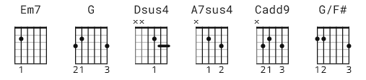

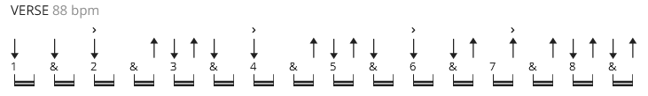

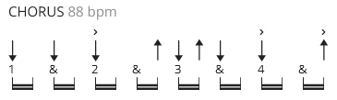

Em7 0-2-2-0-3-3
G 3-x-0-0-3-3
Dsus4 x-x-0-2-3-3
A7sus4 x-0-2-2-3-3
Cadd9 x-3-2-0-3-3
G/F# 2-x-0-0-3-3

[Intro]
Em7 G Dsus4 A7sus4 x4

[Verse 1]
Em7 G
Today is gonna be the day
Dsus4 A7sus4
That they're gonna throw it back to you,
Em7 G
By now you should've somehow
Dsus4 A7sus4
Realised what you gotta do.
Em7 G Dsus4 A7sus4
I don't believe that anybody feels the way I do
Cadd9 Dsus4 A7sus4 (+4 beats which chord TBD )
About you now.

[Verse 2]
Em7 G
Back beat, the word is on the street
Dsus4 A7sus4
That the fire in your heart is out,
Em7 G
I'm sure you've heard it all before,
Dsus4 A7sus4
But you never really had a doubt.

Em7 G Dsus4 A7sus4
I don't believe that anybody feels the way I do
Em7 G Dsus4 A7sus4
About you now.

[Bridge 1]
Cadd9 Dsus4 Em7 (2 bars)
And all the roads we have to walk are winding,
Cadd9 Dsus4 Em7 (2 bars)
And all the lights that lead us there are blinding,
Cadd9 Dsus4 |G G/F#| Em7 (G,G/F# 2 beats)
There are many things that I would like to say to you
G A7sus4 (4 bars)
But I don't know how.

[Chorus]
Cadd9 Em7 G
Because maybe,
Em7 Cadd9 Em7 G
You're gonna be the one that saves me,
Em7 Cadd9 Em7 G
And after all,
Em7 Cadd9 Em7 G Em7 ( 1 strum Em7, the 15 count pause)
You're my wonderwall.

[Verse 3]
Em7 G
Today was gonna be the day,
Dsus4 A7sus4
But they'll never throw it back to you,
Em7 G
By now you should have somehow
Dsus4 A7sus4
Realised what you're not to do.
Em7 G Dsus4 A7sus4
I don't believe that anybody feels the way I do
Em7 G Dsus4 A7sus4
About you now.

[Bridge 2]
Cadd9 Dsus4 Em7
And all the roads that lead you there are winding,
Cadd9 Dsus4 Em7
And all the lights that light the way are blinding,
Cadd9 Dsus4 | G G/F#| Em7 (ea. G= 2 beats)
There are many things that I would like to say to you
G A7sus4
But I don't know how.
[Chorus]
Cadd9 Em7 G
I said maybe,
Em7 Cadd9 Em7 G
You're gonna be the one that saves me,
Em7 Cadd9 Em7 G
And after all,
Em7 Cadd9 Em7 G Em7
You're my wonderwall.

Cadd9 Em7 G
I said maybe,
Em7 Cadd9 Em7 G
You're gonna be the one that saves me,
Em7 Cadd9 Em7 G
And after all,
Em7 Cadd9 Em7 G Em7
You're my wonderwall.

[Outro]
Cadd9 Em7 G
I said maybe,
Em7 Cadd9 Em7 G
You're gonna be the one that saves me,
Em7 Cadd9 Em7 G
You're gonna be the one that saves me,
Em7 Cadd9 Em7 G Em7
You're gonna be the one that saves me,

[Instrumental]
Cadd9 Em7 G Em7 x4

