Yankee Doodle Dandy Cohan

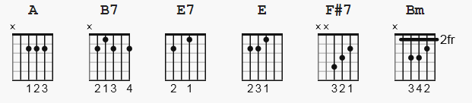

Capo I

Chorus

A B7
I'm a Yankee Doodle Dandy
E7 E A
A Yankee Doodle, do or die
F#7 Bm
A real live nephew of my Uncle Sam
B7 E E7
Born on the Fourth of July
A B7
I've got a Yankee Doodle sweetheart
E7 E A
She's my Yankee Doodle joy
A E7 A E7
Yankee Doodle came to London
A E7 A E7
Just to ride the ponies
B7 E7 E A
I am the Yankee Doodle Boy

I'm the kid that s all the candy
I'm a Yankee Doodle Dandy
I m glad I am
(So s Uncle Sam)
I'm a real live Yankee Doodle
Made my name and fame and boodle
Just like Mister Doodle did, by riding on a pony
I love to listen to the Dixey [Dixie] strain
I long to see the girl I left behind me
And that ain't a josh
She s a Yankee, by gosh
(Oh, say can you see
Anything about a Yankee that's a phoney?)

Father's name was Hezikiah
Mother's name was Ann Maria
Yanks through and through
(Red, white and blue)
Father was so Yankee hearted
When the Spanish War was started
He slipped upon his uniform and hopped up on a pony
My mother's mother was a Yankee true
My fathe' s father was a Yankee too
And that's going some
For the Yankees, by gum

(Oh, say can you see
Anything about my pedigree that s phoney )

A B7
I'm a Yankee Doodle Dandy
E7 E A
A Yankee Doodle, do or die
F#7 Bm
A real live nephew of my Uncle Sam
B7 E E7
Born on the Fourth of July
A B7
I've got a Yankee Doodle sweetheart
E7 E A
She ' my Yankee Doodle joy
A E7 A E7
Yankee Doodle came to London
A E7 A E7
Just to ride the ponies
B7 E7 E A
I am the Yankee Doodle Boy

