Yellow Submarine Beatles key G

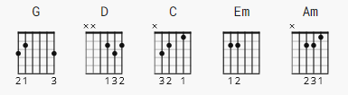

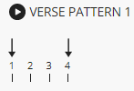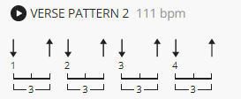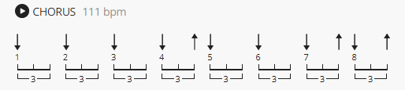

Guitar tuned down ½ step in original recording.

[Verse 1]

(G) D C G
In the town where I was born
Em Am C D
Lived a man who sailed to sea
G D C G
And he told us of his life
Em Am C D
In the land of submarines

G D C G
So we sailed up to the sun
Em Am C D
Till we found the sea of green
G D C G
And we lived beneath the waves
Em Am C D
In our yellow submarine

[Chorus]

G D
We all live in a yellow submarine
D G
Yellow submarine, yellow submarine
G D
We all live in a yellow submarine
D G
Yellow submarine, yellow submarine

[Verse 2]

G D C G
And our friends are all on board
Em Am C D
Many more of them live next door
G D C G
And the band begins to play
[Brass]

G

[Chorus]

G D
We all live in a yellow submarine
D G
Yellow submarine, yellow submarine
G D
We all live in a yellow submarine
D G
Yellow submarine, yellow submarine

[Instrumental] (Verse chords)

G D C G Em Am C D
G D C G Em Am C D

[Verse 3]

G D C G
As we live a life of ease (a life of ease)
Em Am C D
Everyone of us (every one of us) has all we need (has all we need)
G D C G
Sky of blue (sky of blue) and sea of green (sea of green)
Em Am C D
In our yellow (in our yellow) submarine (submarine - aha! )

[Chorus]

G D
We all live in a yellow submarine
D G
Yellow submarine, yellow submarine
G D
We all live in a yellow submarine
D G
Yellow submarine, yellow submarine

G D
We all live in a yellow submarine
D G
Yellow submarine, yellow submarine
G D
We all live in a yellow submarine
D G
Yellow submarine, yellow submarine

(fade out)

NOTE: examples for the verse pattern 1 timing, there is only 1 count
between "I was born" C-G, "lived a man" Em-Am, "sailed to sea" C-D

