You Don’t Have To Say You Love Me Dusty Springfield 1966
key Bm or Em

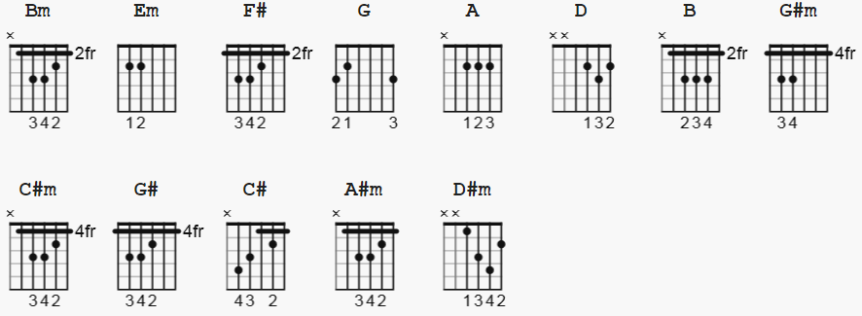

Capo III

INTRO:

Bm Em Em F# G G Bm

Bm Em A
When I said I needed you
D G
You said you would always stay
Em
It wasn't me who changed but you
F#
And now you've gone away

Bm
Don't you see
Em A
That now you've gone
D G
And I'm left here on my own
Em
That I have to follow you
F#
And beg you to come home?

B G#m
You don't have to say you love me
C#m F#
Just be close at hand
B G#m
You don't have to stay forever
C#m F#
I will understand
B
Believe me, believe me

G#m
I can't help but love you
C#m
But believe me
F# Bm
I'll never tie you down
Em A
Left alone with just a memory
D G
Life seems dead and so unreal
Em
All that's left is loneliness
F# Bm
There's nothing left to feel

B G#m
You don't have to say you love me
C#m F#
Just be close at hand
B G#m
You don't have to stay forever
C#m F#
I will understand
B G#
Believe me, believe me

C# A#m
You don't have to say you love me
D#m G#
Just be close at hand
C# A#m
You don't have to stay forever
D#m G#
I will understand
C# B C# B C#
Believe me, believe me, believe me

