You don’t Own Me Lesley Gore key Gm

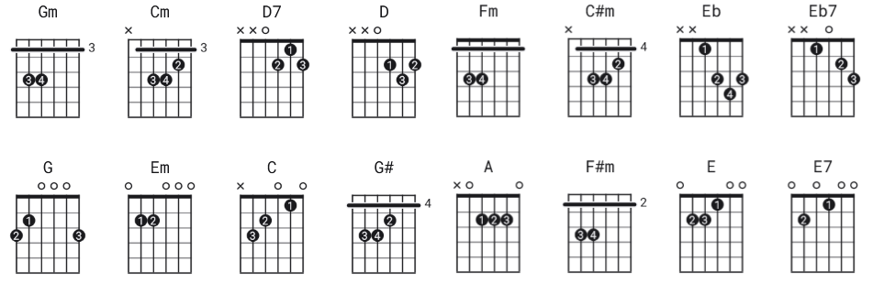
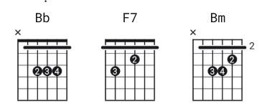

You Don’t Own Me♪♪♫ Lesley Gore ♫♫♪♪

[Intro]

Gm Gm Gm

[verse 1]

Cm D7 Cm D Gm
You don't own me I'm not just one of your many toys
Cm D7 Cm D Gm
You don't own me don't say I can't go with other boys

[Chorus 1]
G
And don't tell me what to do
Em
And don't tell me what to say
C
And please, when I go out with you,
D D7 Gm
Don’t put me on display, 'cause

[Verse 2]

Cm D7 Cm D Gm
You don't own me don't try to change me in any way
Cm D7 Cm D Gm
You don't own me don't tie me down 'cause I'd never stay

[Chorus 2]
G#
Oh, and don't tell you what to do
Fm
Oh don't tell you what to say
C#m
And please when I go out with you
Eb Eb7
Don’t put me on display

[Chorus 3]

A
I don't tell you what to say
F#m
O h I don't tell you what to do
D
So just let me be myself
E E7
That's all I ask of you

[Verse 3]

Bb
I'm young and I love to be young
Gm
I'm free and I love to be free
Eb
To live my life the way I want
F7
To say and do whatever I please

[Outro]

Bb Bm Bb
You don’t own me

