You've Got Another Thing Coming Judas Priest key F#m

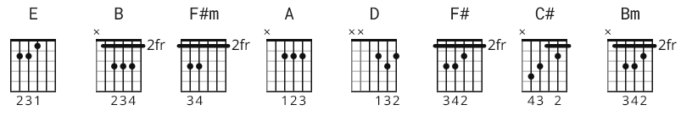

[Intro]
E B F#m B A B (x2)

[Verse]
F#m F#m E F#m
One life , I'm gonna live it up
I'm takin' flight , I said I'll never get enough
Stand tall - I'm young and kinda proud
I'm on top as long as the music's loud

[Chorus]
F#m D
If you think I'll sit around as the world goes by
B F#m
You're thinkin like a fool, cause it's a case of do or die
F# D
Out there is a fortune waiting to be had
B C#
You think I'll let it go , you're mad,
F#m
you've got another thing comin'?
F#m A B F#m F#m F#m A B F#m
you've got another thing comin'?

[Verse]
F#m F#m E F#m
That's right - here's where the talkin' ends
Well listen this night, there'll be some action spent
Drive hard - I'm callin' all the shots
I got an ace card comin' down on the rocks

[Chorus]
F#m D
If you think I'll sit around while you chip away my brain
B F#m
Listen, I ain't foolin' and you better think again
F#m D
Out there is a fortune waiting to be had
B C#
You think I'll let it go, you're mad,
F#m
you've got another thing comin'?
F#m A B F#m F#m F#m A B F#m
you've got another thing comin'?
F#m A B F#m F#m F#m A B F#m
you've got another thing comin'?

[Bridge]
D Bm
In this world we're livin' in,
A F#m
we have our share of sorrow
D Bm
Answer now and don't give in aim
A C#
for a new tomorrow

[Solo]
F#m A B F#m F#m A B F#m F#m A B F#m F#m A B F#m
F#m D B F#m F#m D B C#

[Verse]
F#m F#m E F#m
Oh so hot no time to take a rest yeah
Act tough ain't room for second best
Real strong got me some security
Hey, I'm a big smash I'm goin' for infinity yeah!

[Chorus]
F#m D
If you think I'll sit around as the world goes by
B F#m
You're thinkin like a fool, cause it's a case of do or die
F#m D
Out there is a fortune waiting to be had
B C#
You think I'll let it go, you're mad,
F# F#
you've got another thing comin'?
F# A B F# F#m F#m A B F#m
you've got another thing comin'?
F# A B F# F#m F#m A B F#m
you've got another thing comin'?

[Instrumental]
F#m A B F#m F#m A B F#m F#m A B F#m

[Outro]
F#m A B E B F#m F#m A B
Comin' down! You've got another thing comin'?
E B F#m F#m|A B
You've got another thing comin'?
E B F#m F#m|A B
You've got another thing comin'?
E B F#m F#m|A B
You've got another thing comin'?

