Your Cheatin' Heart Hank Williams Sr.

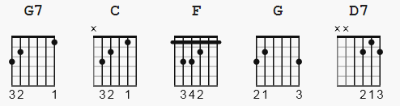

Alternating bass notes

[Intro:]
G7 C

[Verse 1:]
C F
Your cheatin' heart will make you weep
G C
You'll cry and cry and try to sleep
C F
But sleep won't come the whole night through
G C
Your cheatin' heart will tell on you

[Chorus:]
F C
When tears come down like fallin' rain
D7 G
You'll toss around and call my name
C F
You'll walk the floor the way I do
G7 C
Your cheatin' heart will tell on you

[Interlude:]
C F G (x2)

[Verse 2:]
C F
Your cheatin' heart will pine some day
G C
And crave the love you threw away
C F
The time will come when you'll be blue
G C
Your cheatin heart will tell on you

[Chorus:]
F C
When tears come down like fallin' rain
D7 G
You'll toss around and call my name
C F
You'll walk the floor the way I do
G7 C
Your cheatin' heart will tell on you. END

